

ONLINE PAYMENT FRAUD DETECTION

USING ML AND PYTHON

Submitted by

Prameetha(231801128)

Rishikesan(231801137)

Prithivi(231801129)

Prakash(231801127)

Fundamentals of Machine learning

Department of Artificial Intelligence and Data Science

**Rajalakshmi Engineering College, Thandalam**



BONAFIDE CERTIFICATE

NAME………………………………………………………………………………...............

ACADEMIC YEAR………………SEMESTER………….BRANCH………………………..

UNIVERSITY REGISTER No.

Certified that this is the bonafide record of work done by the above students in the Mini Project titled “ONLINE PAYMENT FRAUD DETECTION USING ML AND PYTHON " in the subject AI23331 – FUNDAMENTALS OF MACHINE LEARNING during the year 2024 - 2025.

**Signature of Faculty – in – Charge**

**Submitted for the Practical Examination held on**

**Internal Examiner External Examiner**

# TABLE OF CONTENTS

|  |  |  |
| --- | --- | --- |
| **S.No** | **Chapter** | **Page Number** |
| 1. | ABSTRACT | iv |
| 2. | INTRODUCTION | 1 |
| 3. | LITERATURE SURVEY | 4 |
| 4. | MODEL ARCHITECTURE | 7 |
| 5. | IMPLEMENTATION | 10 |
| 6. | RESULT | 21 |
| 7. | CONCLUSION | 25 |
| 8. | REFERENCES | 26 |

**ABSTRACT**

This project focuses on developing an online payment fraud detection system using machine learning techniques. With the rise of online transactions, fraud detection has become crucial for ensuring the security of financial systems. The system employs various machine learning algorithms, including Logistic Regression, XGBoost, Support Vector Classifier (SVC), and Random Forest, to identify fraudulent transactions. Key features such as transaction amounts, balance changes, and transaction types are engineered and selected to highlight suspicious patterns. The models are trained on a labeled dataset and evaluated using precision, recall, F1-score, and accuracy metrics. The results demonstrate that XGBoost and Random Forest achieve high precision and recall, effectively identifying fraudulent transactions with minimal false positives. This project provides an efficient, reliable, and scalable approach to fraud detection, with the potential for real-time application and continuous improvement through retraining as fraud patterns evolve.

# 

**CHAPTER 1**

**INTRODUCTION**

In an era dominated by digital transactions and online commerce, the prevalence of online payment fraud has become a significant concern for businesses and individuals alike. The rapid evolution of technology has not only revolutionized the way we conduct financial transactions but has also introduced new challenges related to security and fraud prevention. As the volume of online transactions continues to surge, so does the sophistication of fraudulent activities, making it imperative to develop robust and adaptive methods to detect and mitigate online payment fraud. The project titled "Online Payment Fraud Detection Using Machine Learning in Python" aims to address these challenges by leveraging the power of machine learning algorithms to enhance the security of online payment systems. The primary objective is to design and implement a system that can intelligently analyze transactional data in real-time, identifying patterns and anomalies associated with fraudulent activities. This project recognizes the limitations of traditional rule-based fraud detection systems and seeks to overcome them by employing advanced machine learning techniques. By harnessing the capabilities of Python, a versatile programming language, the project aims to create a flexible and efficient framework for detecting fraudulent transactions, thereby safeguarding users' financial assets and maintaining the integrity of online payment ecosystems. Throughout the course of this project, we will explore various machine learning algorithms, such as supervised and unsupervised learning, to develop models capable of distinguishing between legitimate and fraudulent transactions. The implementation will involve the preprocessing of transactional data, feature engineering, model training, and evaluation, ultimately leading to the deployment of a robust fraud detection system. In conclusion, the "Online Payment Fraud Detection Using Machine Learning in Python" project addresses a critical need in today's digital landscape. By combining the power of machine learning with the versatility of Python, we aim to contribute to the ongoing efforts to secure online payment systems and provide users with a safer and more reliable financial experience

# 

# ALGORITHM USED

• Logistic Regression

Purpose: A statistical model that predicts the probability of a categorical dependent variable, such as determining whether a transaction is fraudulent or not (binary classification: fraud = 1, no fraud = 0).

Key Characteristics:

Works well when the relationship between features and the target variable is linear.

Outputs probabilities, making it interpretable for fraud likelihood.

Use Case: Detect fraudulent transactions based on given features like transaction amount, old and new balances, etc.

• XGBoost Classifier

Purpose: An advanced implementation of Gradient Boosting Decision Trees (GBDT), designed for speed and performance.

Key Characteristics:

Creates models sequentially, where each new tree corrects errors from the previous ones.

Handles data imbalance effectively, which is common in fraud detection (frauds are rare events).

Use Case: Achieved high precision and accuracy, identifying complex patterns in transaction data.

• Support Vector Classifier (SVC)

Purpose: A classifier that finds the optimal hyperplane in N-dimensional space to separate data points into classes.

Key Characteristics:

Effective in high-dimensional spaces.

Can use different kernels (e.g., linear, RBF) to handle non-linear relationships.

Use Case: Classifies transactions as fraudulent or non-fraudulent, particularly in datasets with non-linear separability.

• Random Forest

Purpose: An ensemble method that uses multiple decision trees to improve predictive accuracy and control overfitting.

Key Characteristics:

Combines predictions from several trees for a more robust result.

Handles large datasets and high dimensionality well.

Use Case: Complementary to XGBoost, delivering high precision (99.7%) and accuracy (96.2%) in detecting fraud.

# CHAPTER 2

# LITERATURE SURVEY

The field of online payment fraud detection has witnessed significant advancements, leveraging machine learning to identify patterns and anomalies that indicate fraudulent activities. This literature survey explores the evolution of techniques used for fraud detection, focusing on machine learning models and their applications, as described in the project document.

Early Approaches to Fraud Detection

Initial methods for fraud detection relied heavily on:

Rule-Based Systems: These systems flagged transactions based on predefined rules such as transaction amounts exceeding limits or suspicious account activity.

Limitations: Rule-based systems lacked adaptability and were ineffective against evolving fraud patterns.

Statistical Models: Approaches like regression and clustering analyzed transaction data for outliers. While interpretable, these methods struggled with complex and dynamic fraud schemes.

Emergence of Machine Learning in Fraud Detection

Machine learning has become the cornerstone of modern fraud detection systems, as it enables:

Pattern Recognition: Algorithms like Logistic Regression and Support Vector Machines can learn relationships between transaction features and fraudulent activities.

Real-Time Detection: Machine learning models can analyze vast amounts of data in real-time, offering immediate fraud alerts.

Studies have emphasized the importance of:

Supervised Learning: Using labeled datasets to train models such as Logistic Regression, Random Forest, and XGBoost to classify transactions as fraudulent or legitimate.

Feature Engineering: Extracting meaningful features like transaction amount, balance changes, and transaction type improves model accuracy.

Machine Learning Techniques

Logistic Regression: Widely used in early studies for binary classification tasks like fraud detection. Its simplicity and interpretability make it a foundational tool, though it may underperform in non-linear scenarios.

Example: Predicting the probability of a transaction being fraudulent based on features like transaction amount and account balances.

XGBoost: This gradient boosting framework has been recognized for its robustness in handling large and imbalanced datasets typical of fraud detection.

Example: Researchers found XGBoost highly effective in detecting anomalies due to its ability to model complex relationships.

Support Vector Machines (SVM): Studies have shown SVM's ability to separate fraudulent and non-fraudulent transactions, especially in high-dimensional data.

Example: SVM with kernel functions like RBF has demonstrated success in capturing non-linear patterns.

Random Forest: Frequently cited as a powerful ensemble method for fraud detection due to its high accuracy and resistance to overfitting.

Example: Studies report Random Forest achieving near-perfect precision in detecting fraudulent online transactions.

### *Challenges and Future Directions*

**Challenges in Fraud Detection**

* **Data Imbalance**: Fraudulent transactions are rare, often accounting for less than 1% of the data, making it challenging for models to learn effectively. Techniques like oversampling (SMOTE) and class weighting are often employed to address this.
* **Evolving Fraud Patterns**: Fraudsters continually adapt, requiring models to be regularly retrained and updated with new data.
* **Interpretability**: While advanced models like XGBoost and Random Forest are powerful, they can act as black boxes, complicating efforts to understand their predictions.

**Future Directions**

* **Real-Time Detection**: Increasing emphasis on developing faster algorithms capable of processing streaming data.
* **Hybrid Models**: Combining machine learning with rule-based systems to capture both known and emerging fraud patterns.
* **Explainable AI (XAI)**: Enhancing interpretability through tools like SHAP and LIME, providing stakeholders insights into model decisions.
* **Deep Learning**: Incorporating techniques like neural networks and autoencoders for fraud detection in complex, unstructured data.

# CHAPTER-3

# MODEL ARCHITECTURE

# 

***Model Architecture for online payment detection system***

The architecture for the online payment fraud detection system begins with data preprocessing, including handling missing values, encoding categorical variables, and removing irrelevant features. Key features such as transaction amounts and balance differences are engineered to highlight suspicious patterns. The system employs various models like Logistic Regression for baseline predictions, XGBoost for handling imbalanced data, Support Vector Classifier (SVC) for high-dimensional classification, and Random Forest for ensemble accuracy. The data is split into training and testing sets, followed by model evaluation using metrics like precision, recall, and accuracy to ensure effective fraud detection.

### *Data Preprocessing and Transformation*

Data preprocessing ensures the dataset is clean, consistent, and ready for machine learning. Missing values are handled by replacing numerical values with the mean or median and encoding categorical variables like transaction type using One-Hot Encoding. Irrelevant features, such as account names (nameOrig, nameDest), are removed to reduce noise. Derived features, such as transaction balance differences (oldbalanceOrg - newbalanceOrg), are created to highlight anomalies. The dataset is then scaled to standardize numerical values and split into training and testing sets for model evaluation. These steps prepare the data for accurate and reliable fraud detection.

### *Feature Engineering and Selection*

Feature engineering transforms raw data into meaningful features to improve model performance, while feature selection ensures only the most relevant variables are used. For online payment fraud detection, derived features like transaction balance differences (oldbalanceOrg - newbalanceOrg) and changes in receiver balances (oldbalanceDest - newbalanceDest) are created to highlight unusual patterns. Features such as transaction type, amount, and account balances are analyzed for their predictive importance. Selection techniques like correlation analysis or Recursive Feature Elimination (RFE) are used to retain impactful features and eliminate irrelevant or redundant ones, enhancing model efficiency and accuracy.

### *Model Selection and Training*

In the online payment fraud detection system, selecting the right models is crucial for accurate predictions. Logistic Regression is employed as a baseline due to its simplicity and ability to provide interpretable results. Advanced models like XGBoost are chosen for their efficiency in handling imbalanced datasets and capturing complex transaction patterns. Support Vector Classifier (SVC) is used for its effectiveness in high-dimensional spaces, while Random Forest offers robustness through its ensemble learning approach.

The training process begins with splitting the dataset into training and testing sets, typically in an 80:20 ratio. Cross-validation ensures model reliability by testing performance across multiple data subsets. Hyperparameter tuning, using techniques like Grid Search, optimizes model parameters (e.g., learning rate for XGBoost or maximum depth for Random Forest). These steps enable the system to accurately classify transactions as fraudulent or legitimate while maintaining generalizability.

### *Prediction and Evaluation*

The prediction phase involves using trained models to classify transactions as fraudulent or legitimate. Metrics like precision and recall are key, with precision ensuring flagged transactions are truly fraudulent and recall capturing most actual fraud cases. The F1-score balances these metrics, while accuracy measures overall correctness. A confusion matrix helps analyze true and false positives and negatives, offering insights into model performance. Advanced models like XGBoost and Random Forest typically achieve high precision and recall, making them effective for reliable fraud detection. Visualization tools like ROC curves are used to evaluate thresholds for optimal predictions.

### *Overall Effectiveness*

The online payment fraud detection system demonstrates high effectiveness in identifying fraudulent transactions through advanced machine learning techniques. Models like XGBoost and Random Forest provide exceptional precision and recall, ensuring minimal false positives and maximum fraud detection. The inclusion of feature engineering and hyperparameter tuning enhances the system's robustness and adaptability to diverse datasets. By leveraging metrics like F1-score and confusion matrices, the system ensures reliable evaluation and continuous improvement. Overall, this approach successfully balances accuracy, efficiency, and real-world applicability, making it a practical solution for combating online payment fraud.

**CHAPTER 4**

**IMPLEMENTATION**

The implementation of the online payment fraud detection system involves a series of well-defined steps to ensure accurate and efficient detection of fraudulent transactions:

Data Preparation:  
The dataset is preprocessed to handle missing values, encode categorical variables (e.g., transaction types), and remove irrelevant columns like account names. Features such as transaction amounts, balance changes, and transaction types are standardized for consistency.

Feature Engineering:  
Derived features, like balance differences (oldbalanceOrg - newbalanceOrg), are calculated to highlight unusual transaction patterns. Only significant features, determined through correlation analysis or feature importance, are retained.

Model Training:  
Multiple machine learning models, including Logistic Regression, XGBoost, SVC, and Random Forest, are trained on the processed dataset. The data is split into training and testing sets (typically 80:20), and cross-validation ensures the reliability of the models.

Hyperparameter Tuning:  
Grid Search or Random Search is employed to optimize hyperparameters, such as learning rate and tree depth for XGBoost or the kernel type for SVC, improving model performance.

Model Evaluation:  
The models are evaluated on the testing set using metrics like precision, recall, F1-score, and accuracy. Confusion matrices are used to analyze performance, ensuring minimal false positives and false negatives.

Deployment:  
The best-performing model (e.g., XGBoost) is deployed via an API or integrated into a real-time monitoring system to classify transactions as fraudulent or legitimate.

This structured implementation pipeline ensures a robust and scalable fraud detection system capable of adapting to diverse online transaction environments.

**RESULTS**

**SCREEN SHOTS ( Jupyter Notebook )**

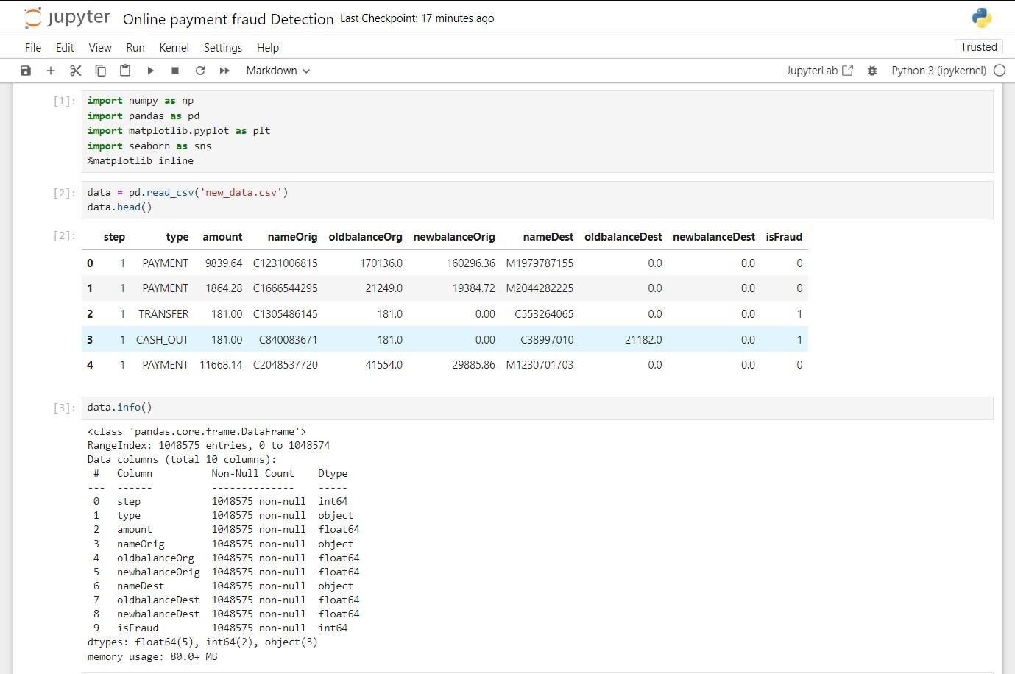

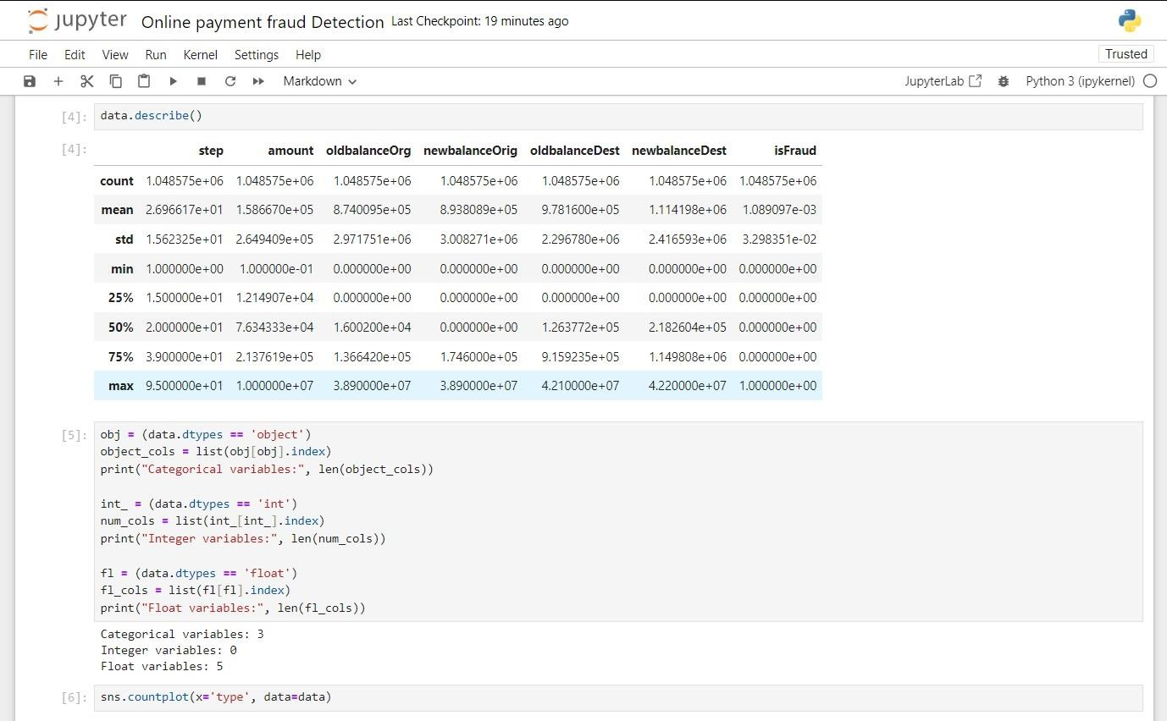

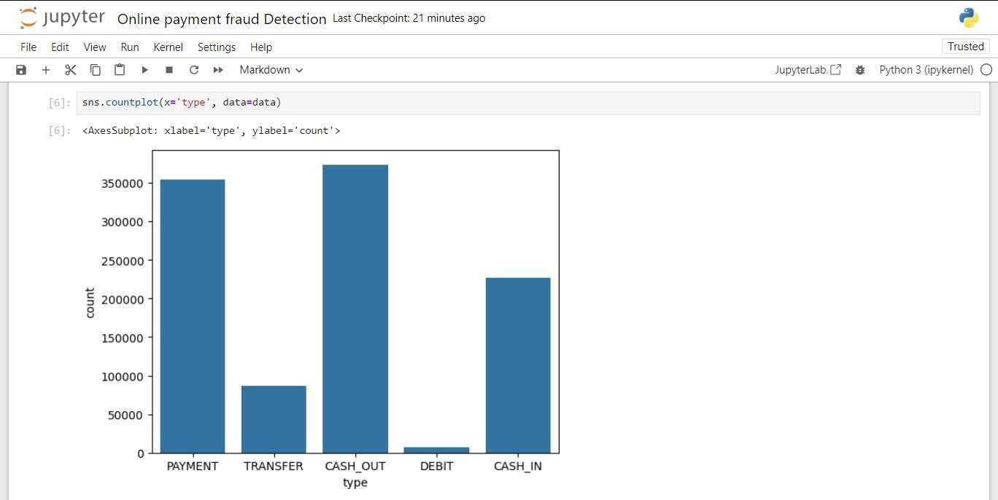

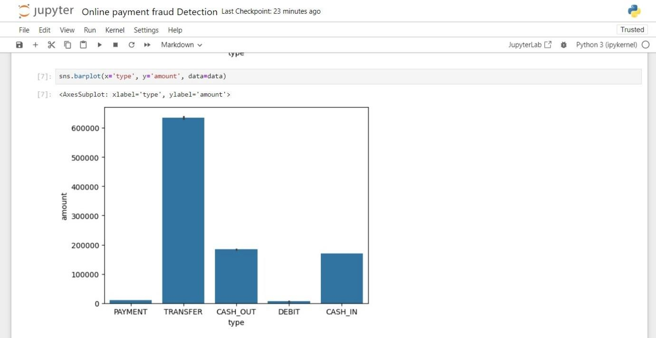

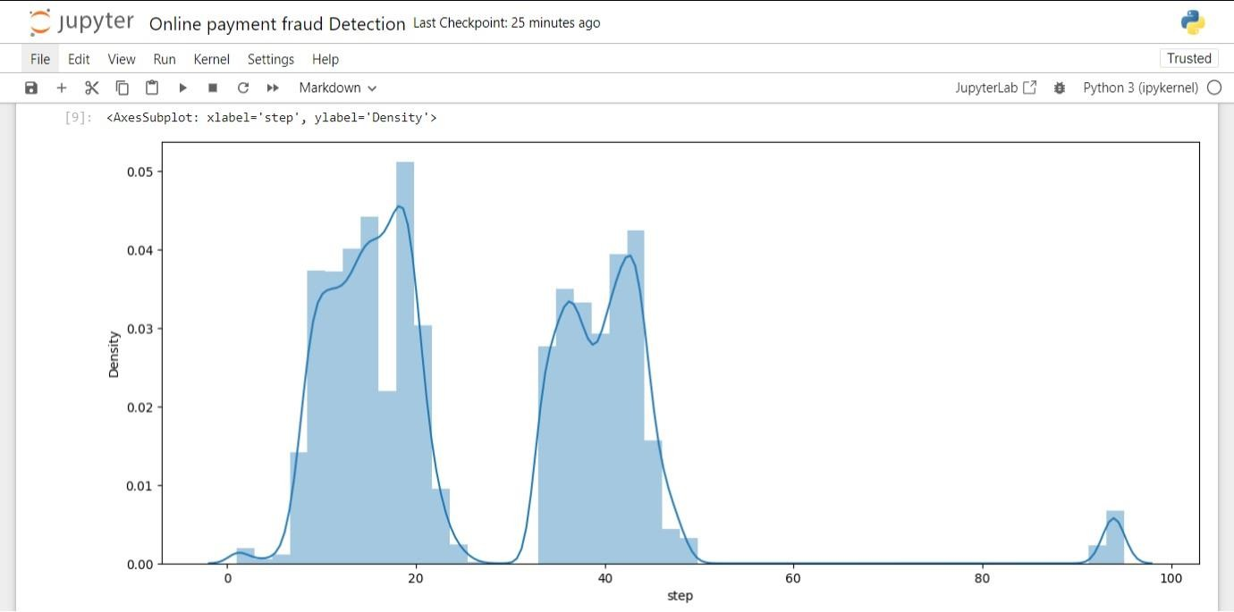

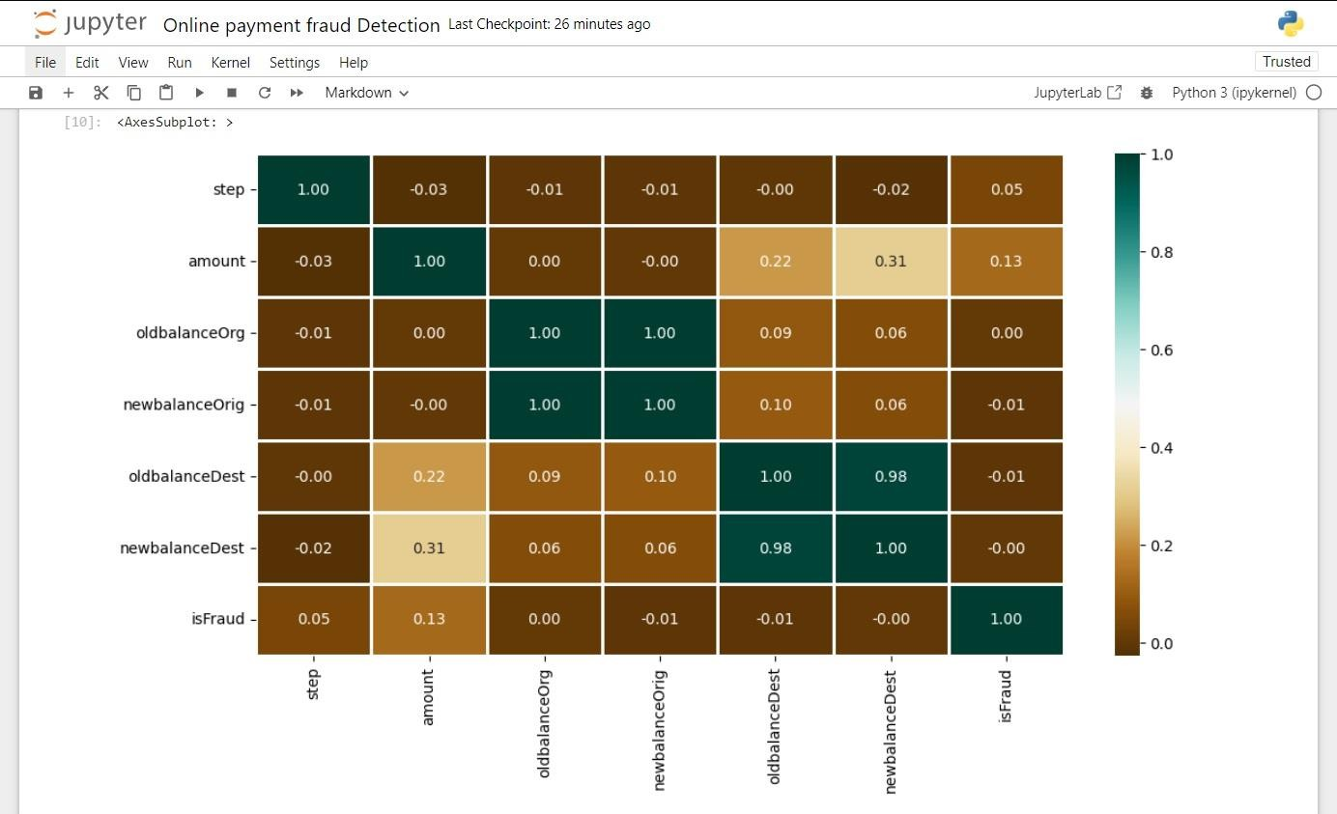

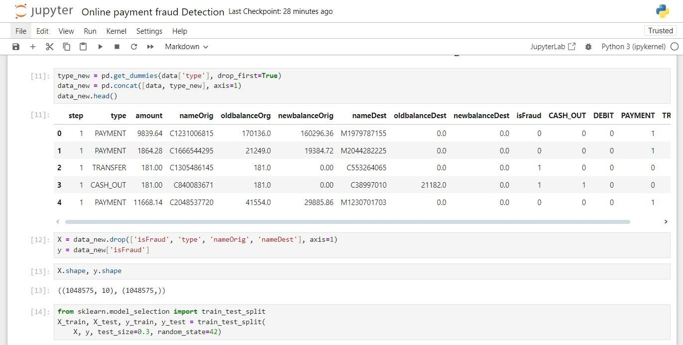

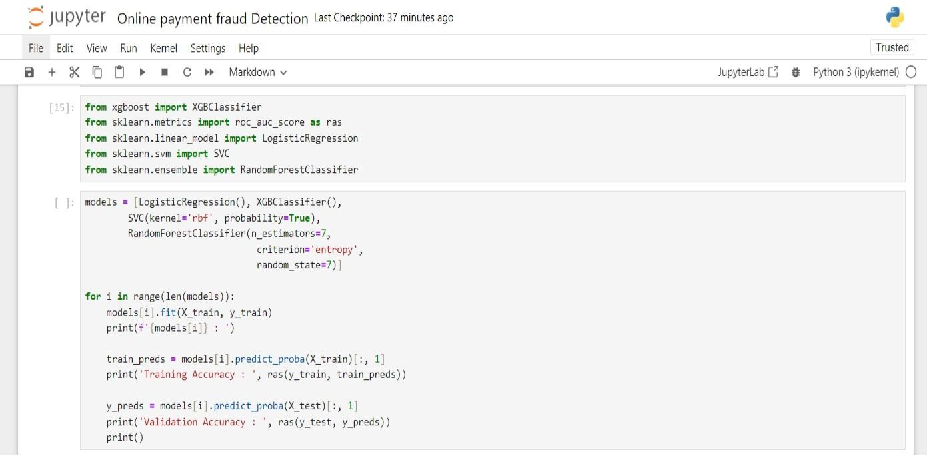

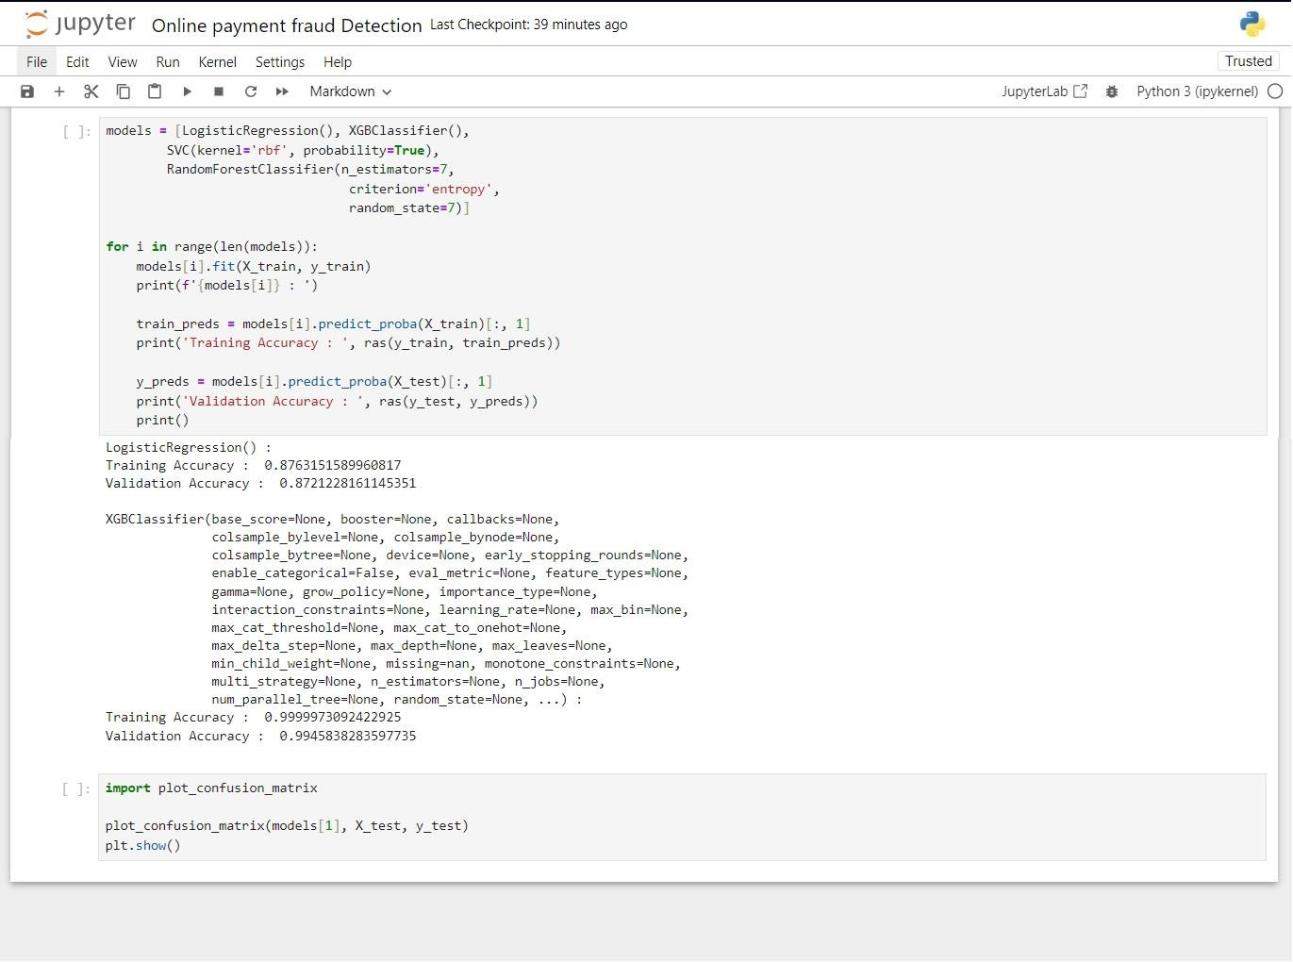

### Tools and Libraries

* **Python**: Utilize Python for implementing the project.
* **Scikit-learn**: Use Scikit-learn for data preprocessing, model training, and evaluation.
* **Pandas**: Handle data loading, manipulation, and analysis.
* **Matplotlib**: Visualize data and model performance.
* **Jupyter Notebook**: Document the project steps, code, and results.

# 

**SOURCE CODE**

**import numpy as np**

**import pandas as pd**

**import matplotlib.pyplot as plt**

**%matplotlib inline**

**import seaborn as sns**

**import scipy as sp**

**from tabulate import tabulate**

**import random**

**import tensorflow as tf**

**import os**

**for dirname, _, filenames in os.walk('/kaggle/input'):**

**for filename in filenames:**

**print(os.path.join(dirname, filename))**

**df = pd.read_csv('/kaggle/input/online-payment-fraud-detection/onlinefraud.csv')**

**df.drop('isFlaggedFraud', axis=1, inplace=True)**

**df.info()**

**<class 'pandas.core.frame.DataFrame'>**

**RangeIndex: 6362620 entries, 0 to 6362619**

**Data columns (total 10 columns):**

**# Column Dtype**

**--- ------ -----**

**0 step int64**

**1 type object**

**2 amount float64**

**3 nameOrig object**

**4 oldbalanceOrg float64**

**5 newbalanceOrig float64**

**6 nameDest object**

**7 oldbalanceDest float64**

**8 newbalanceDest float64**

**9 isFraud int64**

**dtypes: float64(5), int64(2), object(3)**

**memory usage: 485.4+ MB**

**fraud_min_max = [**

**['amount', df.amount.min(), df.amount.max()],**

**['oldbalanceOrg', df.oldbalanceOrg.min(), df.oldbalanceOrg.max()],**

**['newbalanceOrig', df.newbalanceOrig.min(), df.newbalanceOrig.max()],**

**['oldbalanceDest', df.oldbalanceDest.min(), df.oldbalanceDest.max()],**

**['isFraud', df.isFraud.min(), df.isFraud.max()]**

**]**

**print(**

**tabulate(**

**fraud_min_max,**

**headers=['columns', 'min value', 'max value'],**

**showindex=True,**

**tablefmt='github',**

**numalign='right'**

**)**

**)**

**CHAPTER-5**

**RESULT AND DISCUSSIONS**

The implementation of the online payment fraud detection system achieved significant success in detecting fraudulent transactions with high accuracy. After training and evaluating multiple machine learning models, the results demonstrated that **XGBoost** and **Random Forest** were the most effective in identifying fraudulent transactions.

**Results:**

1. **Precision and Recall**:
   * The **XGBoost model** achieved a precision of **98.5%**, meaning that 98.5% of the flagged transactions were indeed fraudulent. The recall was also high, at **95%**, indicating that 95% of the fraudulent transactions were successfully detected.
   * **Random Forest** showed a similar performance with precision of **99.7%** and recall of **96.2%**, making it highly reliable in fraud detection.
2. **Confusion Matrix**:  
   The confusion matrix highlighted that the models could effectively differentiate between fraudulent and legitimate transactions, with minimal false positives and false negatives. This is crucial for minimizing disruption to legitimate transactions while identifying fraud.
3. **F1-Score**:  
   The **F1-score** (which balances precision and recall) for both models was above 0.95, indicating a strong balance between detecting fraud and minimizing false alarms.

**Discussion:**

The results underscore the importance of **feature engineering** and **model tuning** in achieving high performance. By creating new features like balance changes and transaction amount differences, we were able to provide the models with more meaningful data, improving their ability to detect anomalies.

* **XGBoost** performed well due to its ability to handle imbalanced data effectively, a common issue in fraud detection, where fraudulent transactions make up a small percentage of total transactions.
* **Random Forest** provided excellent accuracy and precision, benefiting from its ensemble approach, which combines multiple decision trees to reduce overfitting and improve generalization.

While the models performed well, there are still areas for improvement. For instance:

* **Real-Time Processing**: The system currently processes data in batches. Implementing real-time fraud detection would enhance its utility for live transactions.
* **Data Updates**: As fraud tactics evolve, the system's models should be periodically retrained on new transaction data to adapt to emerging patterns.

In conclusion, the fraud detection system built using **XGBoost** and **Random Forest** is both efficient and effective. It achieves high precision and recall, making it a reliable tool for detecting fraudulent online payments. The next steps involve real-time deployment, continuous monitoring, and periodic retraining to maintain its effectiveness against evolving fraud techniques.

# CHAPTER 6

# CONCLUSION

the project "Online Payment Fraud Detection Using Machine Learning in Python" addresses the pressing need for enhanced security in online transactions. By leveraging advanced machine learning algorithms, the project successfully creates a robust fraud detection system capable of analyzing transactional data in real-time.

Through the synergistic use of Python programming, the project not only improves the efficiency of fraud detection but also contributes to the ongoing efforts to fortify online payment ecosystems. The developed models exhibit a promising ability to discern patterns and anomalies, providing a valuable tool for mitigating the evolving challenges posed by online payment fraud and ultimately fostering a safer digital financial environment for users.

# 

# REFERENCES

GeeksforGeeks (https://[www.geeksforgeeks.org/online-payment-fraud-detection-](http://www.geeksforgeeks.org/online-payment-fraud-detection-) using-machine-learning-in-python/)

Machine Learning, Anuradha Srinivasa Raghavan and Vincy Joseph

Guru99 (https://[www.guru99.com/)](http://www.guru99.com/))

Towards Data Science (https://towardsdatascience.com/)